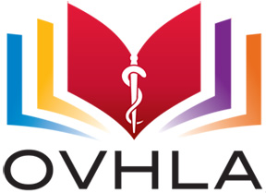
Ottawa Valley Health Libraries Association

Membership Application
Please select one option:
☐ Individual membership ($25)
☐ Institutional membership* ($40)
☐ Student membership ($5)
*Institutional membership allows for 2 voting members or 2 participants at any fee-based event. Additional participants at a fee-based event will be charged the non-member rate.
Please print:
Name: Click here to enter text.
Address: Click here to enter text.
Phone number: Click here to enter text.
Email: Click here to enter text.
Institution name: Click here to enter text.
Please send application forms and payment to:
- By cheque:

Aleksandra Grobelna – OVHLA Treasurer
c/o Canadian Agency for Drugs and Technologies in Health
600-865 Carling Ave.
Ottawa, ON K1S 5S8
Please make cheques payable to: OVHLA (Ottawa Valley Health Libraries Association)

- By e-transfer through online banking:
Please email your application form and transfer funds to: aleksandrag@cadth.ca

